QBA PSYCHIC CALLS REGISTER

Notes for the director: This register is not intended to infer any impropriety in psychic calls, or to deter psyching. It is intended to establish a central repository of the incidence of psyches, so that the frequency of psyches by particular partnerships can be ascertained. Partnerships with a record of frequent psyching are in danger of developing an implicit agreement, and need to be warned about this.
There is an obligation on the psycher to report his/her psyche. Failure to do so will be penalised as a breach of regulation. The director is entitled to award an adjusted score of his own volition (he does not require a complaint from the opponents) if he considers that the psyche has been `fielded'. It is particularly important that any psyches where the director has any doubt should be reported.

EVENT: DATE:
DIRECTOR:

PLAYERS:
North: South:
East: West:
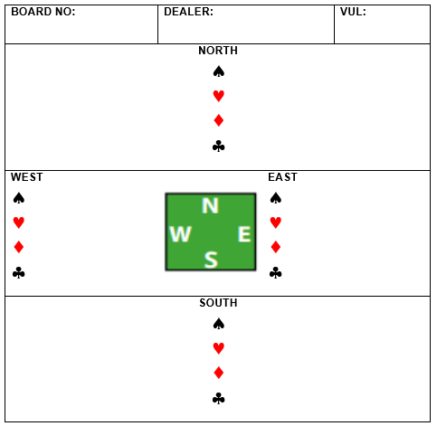
(Please write in players' names clearly)

BIDDING:
West North East South

PLAY (if relevant)

.

RESULT:

Director's comments on reverse, including any adjusted score, warnings given, any history of psyching, general opinion:

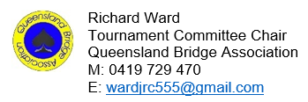
Please forward to:
QBA Tournament Committee chair

